
STREDNÁ PRIEMYSELNÁ ŠKOLA STROJNÍCKA
Fajnorovo nábrežie 5, 814 75 Bratislava, Slovak Republic
Phone/Fax | IČO | E-mail | Website
+421/02/52 96 80 33  +421/02/52 96 84 42 | 030775396  pestuka@centrum.sk | fajnorka@fajnorka.sk  pestuka@centrum.sk | https://www.fajnorka.sk  pestuka@centrum.sk
pestuka@centrum.sk

FINAL YEAR THESIS

PROJECT TITLE

Author: First & Last name (of the author)
Class: V. D
Field of study: Bilingual technical lyceum 3918 M 03

Signature
Internal consultant: Degree. First & Last name (of your internal consultant)
Workplace: SPŠS Fajnorka
Address Fajnorovo nábrežie 5
814 75 Bratislava

Signature

Date of submission: DD<suffix> of Month YYYY
Bratislava YYYY

Abstract
Surname & First name (of the author) Final year thesis: Project title SPŠS Bratislava Project supervisor: First & Last name (of your internal consultant), SPŠS Fajnorka Bratislava, YYYY
Provide a short (informative) description of the content of your final year thesis (usually about half to three-quarters of a page, with a maximum length of one page).
Provide a concise overview of the final year thesis, specifying its focus, objectives, intended application, development process (including the use of suitable software and tools for designing, creating, and building the project, as well as producing a real product). Also include the expected benefits and the target audience.
Keywords: Specify keywords / short phrases (minimum 5, maximum 20), for example: electric motor, clutch, support frame, etc.
Table of contents
Introduction 4
1 Core of the work 5
1.1 Subchapter title 5
1.1.1 Subchapter section title 5
2 Illustrations, tables, equations 6
2.1 Illustrations 6
2.2 Tables 6
2.3 Further subchapters 7
2.3.1 Subchapter structure ..... 7
2.4 Other .... 7
2.4.1 Division of subchapters..... 7
Conclusion 8
Bibliographic sources 9
Attachments 10
Appendix A – CD medium 10
Appendix B – <name of appendix> 10
Appendix C – <name of appendix> 10
Note: Format the content so that it fits entirely on page #3 (in the footer)
CHAPTERS, SUBCHAPTERS, AND SUBCHAPTER SECTIONS ALREADY HAVE FORMATTED PAGE NUMBERS!
Simply change the titles, and the page numbers in the table of contents will update automatically. To refresh the table of contents, right-click on it and select “Update Field.”

Introduction
The main text of the project consists of an introduction, main body (numbered chapters and subchapters of second and up to third level with illustrations and tables), a conclusion, and a list of references. The introduction should not be numbered.
Compared to the brief and informative "Abstract," the introduction refers specifically to the topic being addressed, introduces the issue, characterizes the motivation for its selection, and briefly describes the structure and objectives of the work.
It is not appropriate to repeat in the introduction what is stated in the conclusion. Although the introduction is placed at the beginning, the final version is written by the student only after the entire thesis has been completed.
The introduction begins on page 4 and is optimally 1-2 pages long.

Core of the work
The core of the following chapters is an analysis and synthesis leading to a solution to the problem.

Subchapter title
The subchapters of the thesis serve to structure the text of the thesis for maximum clarity.

Subchapter section title
Edit your work in chapters and subchapters. The numbers of chapters and subchapters (second and third level) are cited in the text of the work as follows:
In the chapter1 , we have already mentioned that ...; ... see2.1 ... etc. ...

The recommended length of the work is 15 (max. 25 pages).
When writing the thesis, the specified length must be adhered to. The cover, title page, preface, table of contents, and appendices are not included in the page count. Only the main part of the thesis, which includes the introduction, conclusion, and list of bibliographic references, is counted. An insufficient length of the thesis cannot be accepted, but exceeding the specified number of pages may also indicate the author's inability to master the selected topic or cope with the assigned task.
- Illustrations, tables, equations
In addition to verbal text, the work may also contain information expressed in pictorial form and symbols.
  - Illustrations
Illustrations are images containing graphs, diagrams, maps, charts, etc. It is not necessary to distinguish between several types of illustrations; it is sufficient to label them all as "Figure". All illustrations must be numbered consecutively throughout the work and must have captions (image titles) for each image. The caption text must be understandable even without context. They should be placed immediately after the text where they are first mentioned (preferably on the same page). The image should be centered if possible. When referring to a given image in the text, use the reference in parentheses (e.g., Fig. 1 ).
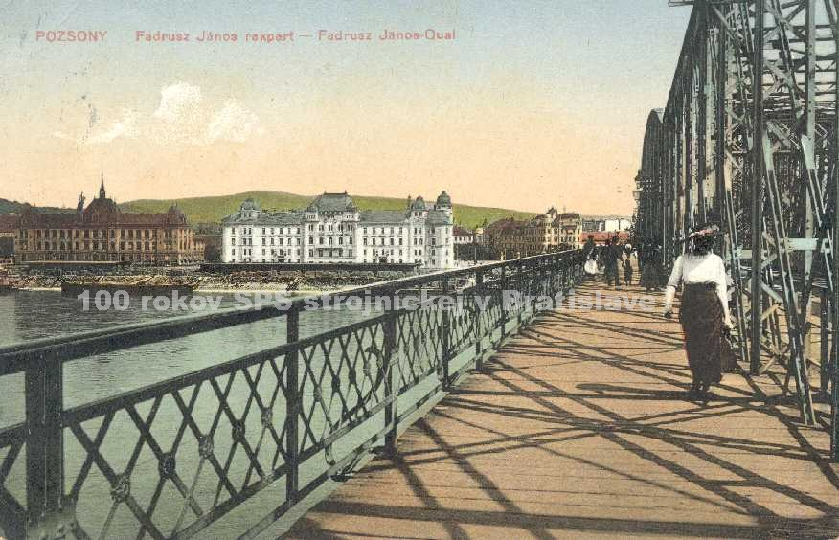
Fig. 1 Mysterious photo
  - Tables
Tables present the ideas and statements described in the work. Any tabular material consisting of more than four or five rows should be presented in table form. The description and table header should be understandable on their own without reference to the text. Headings should express the type of quantity and units in the form "quantity/unit"; the same symbols and abbreviations as in the text should be used. Each table must be numbered and have a title, usually placed above the table. The table should have the same orientation as the text of the thesis document.
Table 1 Class projects
 | 1.A | 1.B | 1.C | 1.D
Presentations | 10 | 12 | 13 | 11
Videos | 7 | 4 | 6 | 3
Computer games | 5 | 6 | 3 | 4
Blogs | 6 | 8 | 7 | 8
Posters | 4 | 3 | 5 | 6
  - Further subchapters

    - Subchapter structure .....

  - Other ....

    - Division of subchapters.....
....
....
....
....

Conclusion
The conclusion contains factual conclusions, a summary, the author's own contribution or perspective, and recommendations from practice (explaining something new to the reader). The conclusion should be no longer than one page.

Bibliographic sources
All documents used in the work must be compiled into a list of bibliographic references, for example, titled the List of References. Standards apply to the preparation of such lists. The purpose is to ensure that each source can be clearly identified and easily retrieved.
The primary source of information for creating bibliographic references is the title page (i.e., the first page of a book containing details such as title, author, etc.) or its reverse side. References may include books, journals, and other information sources (conference proceedings, patent documents, standards, recommendations, theses, personal correspondence and manuscripts, references via intermediary sources, electronic publications) used in the work.
The citation method determines how references are indicated within the document. According to the standard (see STN ISO 690), several citation styles are available. In the numerical citation method, each cited work is listed in the bibliography in the order it is first mentioned and numbered in the text. Numbered references appear in brackets (e.g., [3]) and correspond to the order of first citation. Subsequent citations retain the same number. If specific parts of a document are cited, page numbers may be added after the citation number.
Example of bibliographic sources:
- KALAŠ, Ivan. – BLAHO, Andrej.: Creative Informatics. 1st programming workbook. Bratislava: SPN - Mladé letá, 2007. 48 p. ISBN 80-10-01723-2
- CIMBALA, Roman – BALOGH, Jozef – DŽMURA, Jaroslav: Diagnostics of power transformers using elements of artificial intelligence 1. In: Elektrotechnický magazín ETM. Vol. 14, No. 1 (2004), pp. 8-9.
- Collective authors: State Education Program. [online] Bratislava> ŠPU in Bratislava, 2008. Updated 14.2.2010 [cited 2010-02-17]. Available on the Internet: <http://new.statpedu.sk/sk/filemanager/download/987>
- Electronic diploma and dissertation theses of the Slovak Republic: ETD SK. [online]. Košice: ETD SK, 2004. Updated 14-2-2005 [cited 2005-03-10]. Available on the Internet: <http://www.etd.sk/>.
- Available on the Internet:
<https://sk.wikipedia.org/wiki/Sústruh>

Attachments
List of attachments contained in this document:
- Appendix A – CD medium
- Appendix B – <appendix name>
- Appendix C – <name of appendix>
This section of the thesis contains a list of all appendices. The page numbering of the appendices follows the page numbering in the main text.

Appendix A – CD medium
The attached CD medium must contain the text of the thesis in PDF format. The CD may contain educational hypertext, methodological sheets, questionnaires, and samples of student projects, etc. The CD medium, wrapped in paper packaging, is glued to the inside of the back cover of the thesis.

Appendix B – <name of appendix>
<description of appendix>

Appendix C – <name of appendix>
<description of appendix>

!!!
Do not forget to edit the red text
Do not forget to remove all green notes
!!!

